**Kol Simcha Torah Gazette**

**For parsha beshalach 5785**

Volume 9 Issue 20 (Whole #434) 10 Shevat 5785/ February 8, 2025

**Printed L’illuy nishmas Nechama bas R’ Noach, a”h**

For a free subscription, please forward your request to [***keren18@juno.com***](mailto:keren18@juno.com)

***Past emails can be found on the website ShabbosStories.com under Brooklyn Torah Gazette***

**The “Pink” Chanukah Candles**

**By Daniel Keren**

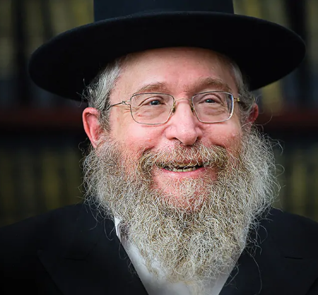

**Rabbi Fischel Schachter**

One of the featured speakers at the January 1st Hakhel Yarchei Kallah Event in Flatbush was Rabbi Fischel Schachter, renowned Maggid Shiur and educator and he spoke on the topic of “Essential Chanukah Lessons and Takeaways.” He began by noting that when you think things can’t get worse, you always get surprised.

The lesson of Chanukah is that there is something deeper and more important within oneself. If someone is very sick, r”l, and one is being fed intravenously, after he recovers and has a seuda hadoh (festival of thanksgiving to Hashem), he can really appreciate that custard.

When a person has difficulty davening, he might wonder whether it is worth the effort and is struggling with his urge to give up praying. Later on when he does manage to daven with great kavanah (concentration and inspiration), it was only because of those time when his earlier davenings were done despite struggles [with his yetzer hora, evil inclination.]

The bald eagle, Rabbi Schachter noted, was recently declared to be the national bird of the United States. Why? Perhaps it is because this bird uses all of it kochos, powers.

Chanukah is about being real about ourselves, about being emestik. What are such situations? When you wish good for someone else, even if that makes the situation more difficult for you as an individual.

**What Does the Ribbono shel Olam Want from You?**

One should realize that picking the right stock doesn’t guarantee you a better Olam Habah (reward in the next World or heaven). Rather one should reflect on what the Ribbono shel Olam (the Master of the World) wants from you.

The Chofetz Chaim and the Imrei Emes were riding together on a train. The Yidden near each stop on the journey came to the station in order to greet and gain inspiration by seeing the holy Chofetz Chaim. On the first stop, the Imrei Emes suggested that the Chofetz Chaim that he open the window and wave to the enthusiastic audience that had come to see him.

The Chofetz Chaim in horror said that he would fall prey to the yetzer hora that would want him to feel great and thereby lose his humility and that would cost him his Olam Habah. The Imrei Emes said that it would be worth it for the Chofetz Chaim to have a diminished Olam Habah if that would result in all the Jews outside of the train getting chizuk, spiritual inspiration by being able to gaze at the holy Jew. Upon hearing that argument of the Imrei Emes, the Chofetz Chaim opened the window and acknowledged the cheers of the audience at the train station.

**The Jewish Couple and Their Young Daughter**

Rabbi Schachter told the story of a Jewish couple and their young daughter trying to escape from the Nazis. They tried to hide in a neighbor’s barn, but the neighbor a goy caught them. He told them that he could not allow them to hide in his barn because if he was caught the German Nazis would automatically execute him and his family for giving refuge to the Jews.

However, he said that he and his wife would take the couple’s daughter because she didn’t look Jewish and that would be safe. Recognizing the truth of their neighbor, they agreed to leave their daughter with the farmer but with the hopes that they might be able to survive and be able to retrieve their daughter. Unfortunately, the husband and wife were soon captured by the Nazis and sent to a concentration camp where the wife died. After liberation, the husband went back to his home town to try and get back his daughter.

When he came to the farmer’s house, he knocked on the door and it was opened by his daughter who had been raised as a non-Jew by the non-Jewish farmer and his wife. The step mother asked the girl who was at the door and was told that a horrible looking man was trying tell a crazy thing, that he was her father.

**Buying Pink Chanukah Candles**

**In a Cold Bitter Snowstorm**

The wife and her husband came to the door and told the man that he had to leave and that he was mistaken that the girl was his daughter. The girl doesn’t recognize him. Trying to figure out what to do he remembered a Chanukah a few years before the nightmare began. He recalled buying a set of candles to light the menorah. His daughter cried that she wanted only pink candles. Trying to calm her down, he went out in a cold bitter snowstorm to acquire those purple candles that his daughter was crying for. He got them and thus pacified the daughter.

He then asked the girl if she remembered those pink candles that he got for her on that stormy night for the Chanukah menorah. After a few seconds, she looked at him and cried out “Tatty! Tatty!” And she swung her arms around him and left with him and grew up to be a true Jewish woman, and was blessed to marry a Jewish man and develop a wonderful family. All because of the memory of those “pink” candles on a cold Chanukah night.

In the Ner Chanukah, we get a vision of our future. We live in a world of great darkness. But the light of Chanukah even during the darkest night of the year can give one the powerful insight to make sense in all the craziness surrounding us.

**Thoughts that Count for Our Parsha**

***And the one came not near the other all the night (Ex. 14:20)***

As the Talmud relates, the ministering angels wanted to sing songs of praise as the Egyptians were drowning in the Red Sea. However, G-d stopped them by pointing out the inappropriateness of rejoicing at a time when "the work of My hands is drowning." An analogy is given of a serious yet necessary operation to save a patient's life. During the painful surgery, there is no room for rejoicing. Only after its successful completion can one begin to offer praise and speak of its benefits. (Yeshuot Malko)

*Reprinted from Parshat Beshalach 5762/2002 edition of L’Chaim.*

**Rav Avigdor Miller on**

**Thanking Hashem**

**for Gentile Gifts**

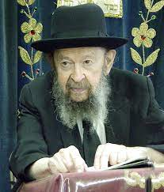

***QUESTION:*** What should a person think when looking at a bridge?

**ANSWER:** Now, it’s not a foolish question. The Chovos Halevovos tells us a very important point which we should make use of all the time. He says that one of the first functions of the oved Hashem is to see what Hakodosh Boruch Hu has done for him. טוב להודות לה׳ – What’s good in this world? To thank Hashem. You must spend time thinking about what He did for you. And so, the Chovos Halevovos starts telling about all the things Hakodosh Boruch Hu is doing for us. Pages and pages.

Then we he gets through all these things he adds an important point. He says that we also have to thank Hakodosh Boruch Hu for the נימוסי האומות, for the things that the nations of the world instituted. When you see certain things that the gentile did and they are good for us you have to thank Hashem who gave them the idea to do it.

And so, we see traffic lights; it’s only a light after all but it adds so much convenience to our lives. I remember once upon a time when there were no traffic lights; no traffic lights. In busy places a policeman stood and he said, “Go, go.” But on other streets, nothing.

When traffic lights were invented we appreciated it no end. It was a wonderful thing. But it wasn’t like these traffic lights. It was plain stop and go sign that turned around. Stop, go, stop, go. No lights. But now there are lights everywhere. Boruch Hashem! Lights are life savers! And you’re supposed to thank Hashem for the lights, yes! You never thanked Hashem for the traffic lights?! Get busy now. Think about that. Because an oved Hashem must thank Hakodsh Boruch Hu for the things that the goyim invented.

You should thank Him for the traffic laws too. How do you know that the person driving the car will stop and let you pass by when there is a red light? Maybe he’ll speed through. No, you have confidence that they are afraid of the police; that’s they’ll get a traffic summons for a violation. You rely on that. As you cross, there is a rasha, an antisemite, and he’s looking at you. He has a big yetzer hara but he’s afraid to do it, and so he sits still. So, you thank Hakodosh Boruch Hu who put this idea into the head of the goyim to create traffic lights and traffic laws. It’s a wonderful thing!

And so, when you see a bridge, so you think about how the bridge is a reason why you can go over it and go to good places. I once learned in a yeshiva in Manhattan. Way back, sixty-eight years ago, I went to a yeshiva in Manhattan. And I lived in Brooklyn, in Williamsburg, and we had to cross the bridge. The bridge was made to bring me to the yeshiva!

The Rambam says that. Forget about all the goyim that travel on the bridge; that’s just agav urcha. The bridge is made for you! For going to learn torah by crossing the bridge. So, the bridge is a gift from Hakodosh Boruch Hu. That’s how you should look at a bridge.

And all the things that the umos ha’olam invented are the same. You have to thank Hakodosh Boruch Hu that He gave us artificial lights. By the way, people don’t know that every week we thank Hashem for lights. Every day we thank Hashem for the natural light of the sun, but for artificial light we thank once a week, on motzei Shabbos. בורא מאורי האש.

What’s that? Did you ever think about that? We’re thanking Hashem for artificial lights. Some people think it’s just a ceremony, a frumkeit. No! We’re makir tov for electricity and all other forms of artificial light. After all, in the olden days when it was night time, what could you do? You could sit down and learn ba’al peh if you remembered but if you didn’t have such a good memory you couldn’t learn. And now boruch Hashem, Hakodosh Boruch Hu gave lights.

And He also told a certain German named Gutenberg, “Get busy Mr. Gutenberg and invent the art of printing.” And so, Gutenberg, in the 1400’s, invented printing. And as soon as Gutenberg invented printing, the Jews seized hold of it – they began printing the Shas immediately. Among the first ones who utilized the invention of printing were the Jewish people. Such a wonderful thing! And so, we thank Hakodosh Boruch Hu for that.

In the olden days a sefer cost as much as a farm. To write a sefer could cost as much as a farm! The ba’alei tosfos didn’t have the whole shas. Who could afford a whole shas?! And boruch Hashem people have a shas in every home today. We have to thank Hakodosh Boruch Hu that he told a goy in the 1400’s to go ahead and invent printing. So, all the things that the goyim did were instigated by Hashem. Traffic light and traffic laws and light bulbs and printing and bridges, it’s all a part of the chasdei Hashem. And it’s up to us that besides for all the things we thank Him for, we have to thank Him for these things as well.

*Reprinted from a recent email of Toras Avigdor, - (based on Tape #E-8 – May 1995)*

**The Power of Jewish Children Learning Torah and the Miracles**

**That Such Learning Generates**

**From the Teachings of the Lubavitcher Rebbe**

**Rabbi Menachem Mendel Schneerson, Zt”l**

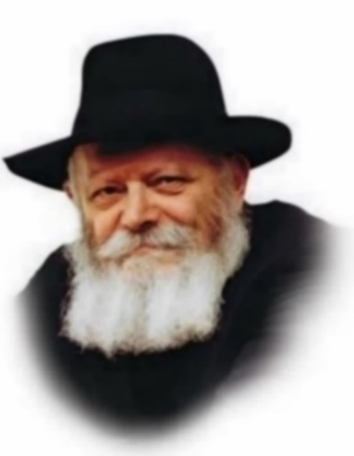

This week's Torah portion of Beshalach describes the miracle of the splitting of the Red (Reed) Sea. With the Egyptians in hot pursuit, the Jewish people found their way blocked by a body of water. The Sea then parted, "and the waters were a wall to them on their right and on their left."

In what merit did G-d perform such a miracle? Our Sages teach that it was in the merit of the Jewish children, who "recognized [G-d] first" - even before Moses, Joshua and all the elders. These children, who had been born into slavery yet had nonetheless been given a proper Jewish education - were the first to declare, "This is my G-d, and I will glorify Him."

Born in exile, the generation of children who went out of Egypt keenly perceived their status as "the smallest of all the nations." They knew that the Egyptian lifestyle was in stark contradiction to the Jewish way of life. And yet, they clung to their Judaism and were proud of it. Empowered by the Jewish education they received from their mothers, they did not hesitate to leave the "fleshpots of Egypt" for the "great and terrible desert," even though they did not have enough provisions. Rather, they had absolute trust and faith in G-d, and in their merit the Red Sea split.

With such children, there is no need to be alarmed. The Jewish people were surrounded on all sides, yet in the children's merit they marched into the Sea and the waters parted.

The miracle of the splitting of the Red Sea was extraordinary for another reason: Not only was the obstacle that stood in their way removed, but the waters themselves became a protective wall that shielded them from harm. This is the highest level of overcoming difficulties and hurdles, and it too came about in the children's merit. When Jewish children are given the kind of education that enables them to "recognize G-d first," the impediments themselves are transformed into a protective wall.

When a Jewish child knows that the only reality in the world is holiness, and that nothing can stop him from fulfilling G-d's will, he merits that all ostensible obstacles will not only vanish but actually help him in his Divine service.

Thousands of years later, the Jewish people are still in need of miracles. As "one sheep among seventy wolves," our entire existence is an ongoing supernatural miracle, like the splitting of the Red Sea.

In order to deserve this merit, we need to make sure that all Jewish children can benefit from a Torah-true Jewish education. We will then have the pleasure and nachas of seeing them "recognize G-d first" - even before their parents and grandparents.

*Adapted from Volume 2 of Likutei Sichot*

*Reprinted from Parshat Beshalach 5762/2002 edition of L’Chaim, a publication of the Lubavitcher Youth Organization. Adapted from Volume 31 of Likutei Sichot*

**Rabbi Berel Wein on**

**Parshat Beshalach 5785**

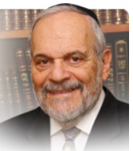

The miracle of the manna that fell from heaven and nurtured millions of people for forty years is one of the focal points of this week’s parsha. The obvious reason for the miracle’s occurrence is that the Jewish people had to have daily nourishment simply to survive. However, the rabbis of the Talmud injected another factor into the miracle of the falling manna. They stated that “the Torah could only have been granted to those that ate manna daily.” Thus, the necessity for the manna was directly associated with the granting of the Torah to the Jewish people on Mount Sinai. No manna, no Torah. Why is this so?

Most commentators are of the opinion that only a people freed from the daily concerns of earning a living and feeding a family could devote themselves solely to Torah study and acceptance of the life values that acceptance of the Torah mandates.

The Torah is a demanding discipline. It requires time and effort, concentration and focus to appreciate and understand it. Cursory glances and even inspiring sermons will not yield much to those who are unwilling to invest time and effort into its study and analysis. This was certainly true in this first generation of Jewish life, newly freed from Egyptian bondage and lacking heritage, tradition and life mores that would, in later generations, help Jews remain Jewish and appreciate the Torah.

The isolation of the Jewish people in the desert of Sinai coupled with the heavenly provision of daily manna and the miraculous well of Miriam all together created a certain think-tank atmosphere. This atmosphere enabled Torah to take root in the hearts and minds of the Jewish people.

In his final oration to the Jewish people, recorded for us in the book of Devarim, Moshe reviews the story of the manna falling from heaven. But there Moshe places a different emphasis on the matter. He states there that the manna came to teach, “… that humans do not live by bread alone but rather on the utterances of G-d’s mouth,”

To appreciate Torah, to truly fathom its depths and understand its values system, one has to accept its Divine origin. Denying that basic premise of Judaism compromises all deeper understanding and analysis of Torah. The manna, the presence of G-d, so to speak, in the daily life of the Jew, allowed the Torah to sink into the depths of the Jewish soul and become part of the matrix of our very DNA.

The Torah could only find a permanent and respected home within those who tasted G-d’s presence, so to speak, every day within their very beings and bodies. The rabbis also taught us that the manna produced no waste materials within the human body.

When dealing with holiness and holy endeavors there is nothing that goes to waste. No effort is ignored and no thought and attempt is left unrecorded in the heavenly court of judgment. Even good intent is counted meritoriously. Let us feel that we too have tasted the manna.

*Reprinted from the current website of rabbiwein.com*

*\*\*\*\*\*\*\*\*\*\*\*\*\*\*\*\*\*\*\*\*\*\*\*\*\*\*\*\*\*\*\*\*\*\*\*\*\*\*\*\*\*\*\*\*\*\*\*\*\*\*\*\*\*\*\*\*\*\*\*\*\*\*\*\*\*\**

**Go out and fight with Amalek (Ex. 17:9)**

Why were the Jews told to do nothing before the splitting of the Red Sea, whereas they were encouraged to actively wage battle against Amalek? In general, in most areas of life, a Jew must have simple faith that G-d will provide him with all his needs, independent of human effort and intervention. However, when it comes to the struggle for Judaism (Amalek is symbolic of everything that is antithetical to holiness), passive faith is not enough, and practical action is required (Pardes Yosef)

*Reprinted from Parshat Beshalach 5762/2002 edition of L’Chaim.*

**14 Facts About Syrian Jews**

**By**[**Menachem Posner**](https://www.chabad.org/search/keyword_cdo/kid/12145/jewish/Posner-Menachem.htm)

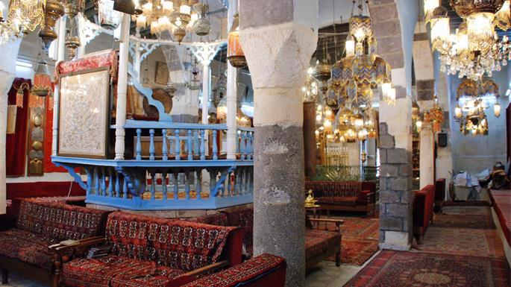

**Ancient synagogue in Jobar, near the center of Damascus, named for Elijah the Prophet, and destroyed in the Syrian Civil War in 2014 (photo courtesy of Chrystie Sherman/Diarna.org).**

**1. Jews Have Lived There Since the Dawn of Our Nation**

Before G‑d called on him to travel west to the Holy Land, Abraham, the father of our nation, lived in what is now Syria.[1](javascript:doFootnote('1a5585072');) Years later, King David captured much of that territory,[2](javascript:doFootnote('2a5585072');) which attained a status of quasi-sanctity, not quite like the Land of Israel proper, but not like the Diaspora either.[3](javascript:doFootnote('3a5585072');)

**2. There Are Halabi and Shami Jews**

The two greatest centers of Jewish life were in Aleppo and Damascus. Aleppo is referred to in Hebrew as *Aram Tzova* (pronounced *Aram Soba*, by Syrian Jews). Its Arabic name is *Halab* (which was mangled into “Aleppo” in English), and its people are referred to as Halabi.

Damascus is referred to among Syrians as *Al-Sham*, and the Jews of Damascus and their descendants are referred to as Shami.

**3. There Were Many Notable Syrian Rabbis**

The classic collection *Likdosim Asher Baaretz* by Rabbi David Laniado lists hundreds of notable Syrian scholars, each of whom contributed to the advancement of Torah learning.[4](javascript:doFootnote('4a5585072');) Here is a sampling of some of the best-known scholars, some of whom called Syria home and some who just passed through:

[**Rabbi Saadia Gaon**](https://www.chabad.org/library/article_cdo/aid/112319/jewish/Rabbi-Saadia-Gaon.htm) (c. 882-942): Brilliant leader of the Babylonian [Torah](https://www.chabad.org/library/article_cdo/aid/1426382/jewish/Torah.htm) academy [who rendered the entire Torah into flowing Arabic](https://www.chabad.org/news/article_cdo/aid/3455942/jewish/One-Mans-Project-Rendering-an-Epic-Torah-Commentary-into-Modern-Arabic.htm), and whose teachings and traditions remain central to Judaism today. While in Aleppo, he was instrumental in preventing the Jewish world from fragmenting into a situation that would have involved different places using different calendars.

Rabbi Yosef Bar Yehuda (c. 1160–1226): A student of Maimonides, he was an outstanding scholar, physician, and philosopher in Aleppo, where he lived for many years. [Maimonides](https://www.chabad.org/library/article_cdo/aid/889836/jewish/Maimonides-The-Rambam.htm) wrote the *Guide to the Perplexed* to assist him in his efforts to reconcile his philosophical beliefs with belief in [G‑d](https://www.chabad.org/library/article_cdo/aid/433240/jewish/God.htm).

The Dayan Family: As their name indicates (*dayan* is Hebrew for “judge”), successive members of the Dayan family, direct descendants of King David, served as rabbis in Aleppo for centuries.

Rabbi Shemuel Laniado (--1605): Born in Aleppo to Sephardic parents, he studied under Rabbi Yosef Karo in Safed before returning to his hometown where he served as chief rabbi for four decades. He was known as the *Baal Hakelim,* because the titles of many of his published works began with the word *keli.*

**4. Aleppo Had a Giant Synagogue Complex**

The Great Aleppo Synagogue (known locally as *al safra,* “the yellow”) was actually a complex with several synagogues, including an outdoor sanctuary that was used during the dry summer months. It had seven holy arks on the southern wall, consistent with the tradition that synagogues face toward Jerusalem (Aleppo is north of [Jerusalem](https://www.chabad.org/library/article_cdo/aid/4246466/jewish/Jerusalem.htm)).

The synagogue was destroyed during the 1947 violence that broke out after the UN’s declaration of the partition of Palestine. It has since been partially restored but is rarely, if ever, used.

**5. The Aleppo Codex Was Their “Crown”**

For more than five centuries, the Jews of Aleppo were stewards of a priceless annotated text of the entire Tanach, known as Keter Aram Tzova (“The Crown of Aleppo”) or the Aleppo Codex, thus named because it was bound as a book (“codex”) as opposed to the traditional scroll format.

The book—which was produced by the famous Ben Asher family of Tiberia—came to Damascus along with a descendant of Maimonides, who treasured the [Keter](https://www.chabad.org/kabbalah/article_cdo/aid/380778/jewish/Keter.htm) and consulted it in his own quest to identify the most proper and accurate Torah text.

Unfortunately, a portion of the Codex went missing when the Great Aleppo Synagogue was destroyed in 1947. The remainder is now housed in the Shrine of the Book in Jerusalem.

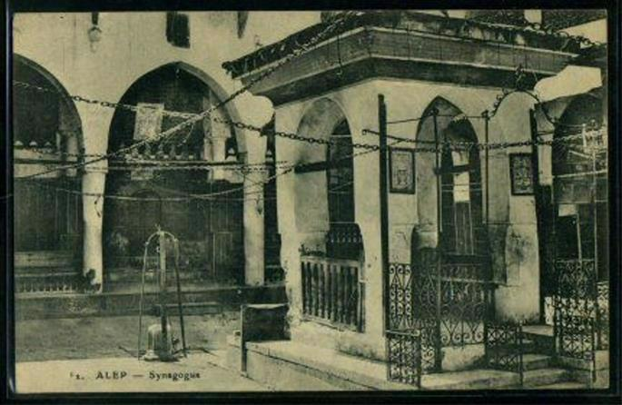

Postcard showing of the outdoor section of the Great Synagogue of Aleppo (scan courtesy of Diarna.org).

**6. They Were Joined (and Dominated) by Sepharad**

In the wake of the Catholic persecution of Jews in the Iberian Peninsula, which culminated with the Spanish expulsion of 1492 and the Portuguese expulsion of 1496, Spanish Jews (Sephardim) streamed into the relative tolerance of Muslim Arabia, including Syria. The [Sephardim](https://www.chabad.org/library/article_cdo/aid/2617014/jewish/The-Rise-of-the-Sepharadim.htm) were originally separate from the native Jews (Musta’arabim), forming their own communal infrastructure and maintaining their own traditions. In time, [Sephardic](https://www.chabad.org/library/article_cdo/aid/2617014/jewish/The-Rise-of-the-Sepharadim.htm) customs and traditions dominated, and all Jews of Syria identified as Sephardic.

**7. Their Language Was Arabic**

Historically, the Jews in Syria spoke Arabic, similar to their non-Jewish neighbors. When Sephardim originally converged on Syria, they brought along their language, Ladino, or Judeo-Spanish. However, after hundreds of years of becoming one with the existing Arabic-speaking locals, [Ladino](https://www.chabad.org/library/article_cdo/aid/1085545/jewish/Will-Ladino-Rise-Again.htm) was largely forgotten among the descendants of the Spanish exiles.

**8. Some Light an Extra Chanukah Candle**

On [Chanukah](https://www.chabad.org/holidays/chanukah/default_cdo/jewish/Chanukah-Hanukkah-2025.htm), some Syrian descendants of the Spanish exiles light a second *shammash* candle on the menorah, celebrating their ancestors’ safe flight from the Spanish Expulsion.

**9. They Have a Rich and Unique Canon of Synagogue Music**

For hundreds of years, Syrian Jews have woken early on winter Shabbat mornings to sing *bakkashot* (prayer hymns). Some of them were composed by the great Sephardic Kabbalists and are known across the Jewish community, but others were composed and are sung only in the Syrian community.

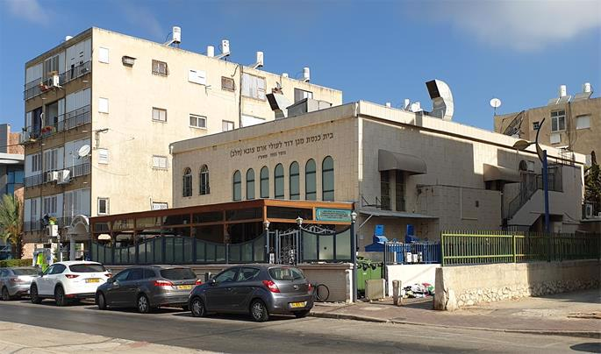

**In Holon, Israel, the Magen David Synagogue serves Jews from Syria and their descendants (photo: Roman Yanushevsky).**

**10. Syrian Jews Live All Over**

The fabric of the Syrian economy began to unravel in the mid-19th century, when the industrial revolution and the opening of the Suez canal meant that there was much less East-West trade passing through Syria. As Jews emigrated elsewhere, a Syrian diaspora sprung up in Israel, the United States, Argentina, Mexico, Brazil, Panama and elsewhere.

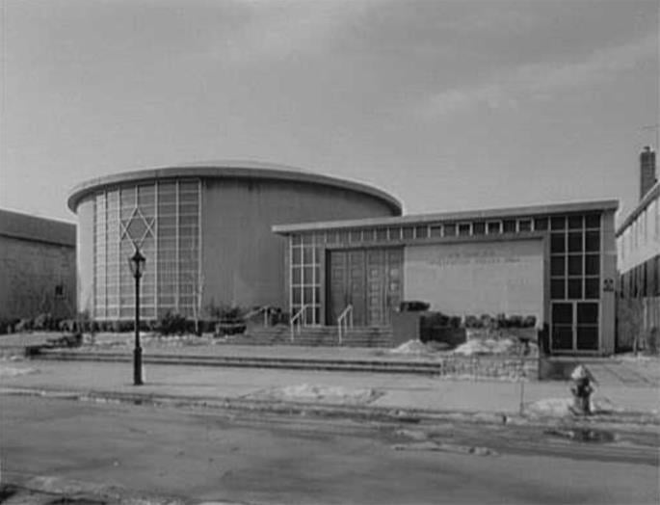

**The Shaare Zion Synagogue in Brooklyn as it appeared in 1964. (photo: Library of Congress).**

**11. There Are Large Communities in Brooklyn and Deal**

Since the early 20th century, Brooklyn, N.Y., has been home to a large and prosperous Syrian Jewish community, whose grand synagogue, Shaare Zion, was among the largest Orthodox congregations in North America.

There is also a Syrian-Jewish population in Deal, a small town in Central New Jersey, where the overwhelming majority of the residents are Syrian Jews, served by a growing bevy of synagogues, yeshivot, and communal organizations.

**12. They Famously Banned Conversion**

Fearing that their rapidly assimilating community members would arrange perfunctory “conversions” for non-Jewish lovers, Syrian rabbis in Argentina—and later on in the US—decreed that no conversions would be performed and that no Syrian Jews could marry converts.

**13. Jews Were Persecuted Out of Existence in Syria**

The 55,000 Jews in Syria after the establishment of Israel were severely restricted, and by 1964, there were barely 5,000 left. They were even more harshly persecuted, and they were not even allowed to travel from city to city. Their every move was watched by the Mukhabarat (secret police). The more they were tortured and confined, the more determined people were to leave Syria.

**14. Many Were Saved by a Canadian Widow**

A young widow with six children, Judy Feld Carr was a musicologist living in Toronto who learned of the plight of the Jews imprisoned in Syria in the early ‘70s. Known simply as “Mrs. Judy in Canada” she secretly arranged ransoms, oversaw escapes, and orchestrated other daring operations to save as many as 3,228 lives.

Except for 20 or 30 souls, all remaining Jews left Syria when Hafez al-Assad opened the doors in the early ‘90s, and today there are no more than perhaps a dozen Jews left in Syria, mainly in Damascus.[5](javascript:doFootnote('5a5585072');)

**Footnotes**

[1.](https://www.chabad.org/library/article_cdo/aid/5585072/jewish/14-Facts-About-Syrian-Jews.htm" \l "footnoteRef1a5585072) There is frequent reference to Abraham’s kin living in Aram Naharayim (or Padan Aram), and Abraham’s servant, Eliezer, is described as “Damesek,” which can be understood to mean that he is from Damascus.

[2.](https://www.chabad.org/library/article_cdo/aid/5585072/jewish/14-Facts-About-Syrian-Jews.htm" \l "footnoteRef2a5585072) See II Samuel 10 and Psalms 60.

[3.](https://www.chabad.org/library/article_cdo/aid/5585072/jewish/14-Facts-About-Syrian-Jews.htm" \l "footnoteRef3a5585072) According to Rashi, this was because David’s conquest was seen as a personal campaign, not a communal endeavor. According to Maimonides, however, it was because David should have first shored up the territories closer to home before marching out to conquer Syria (Hilchot Terumot 1:3).

[4.](https://www.chabad.org/library/article_cdo/aid/5585072/jewish/14-Facts-About-Syrian-Jews.htm" \l "footnoteRef4a5585072) Translated and greatly expanded as *Aleppo: City of Scholars (Sutton, Rabbi David, Artscroll, Brooklyn, 2005).*

[5.](https://www.chabad.org/library/article_cdo/aid/5585072/jewish/14-Facts-About-Syrian-Jews.htm" \l "footnoteRef5a5585072) The author thanks Rabbi Dr. Elie Abadie for reviewing this article and adding his insights and corrections.

*Reprinted from the current website of Chabad.Org*